ASSIGNMENT - DIGITAL MARKETING

|  |  |
| --- | --- |
| Reg No | 962820106003 |
| NAME | Abishek Nigal.V |
| NM ID | 097E29F5FD10A0B94734BE30D79E71CB |
| Date | 22-10-2023 |

1.Create a blog or website using Blogspot and WordPress. Customize the theme design and post new article with 500 words.

Link: https://vendatravels.blogspot.com/2023/08/venda-travels.html

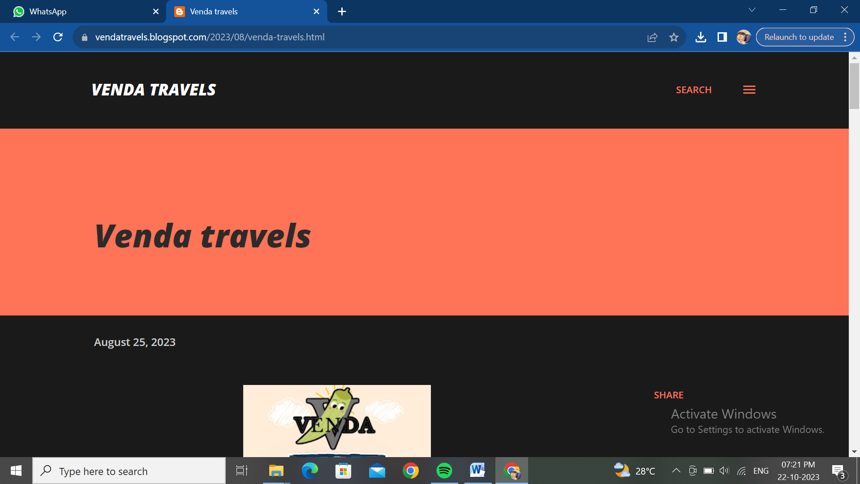

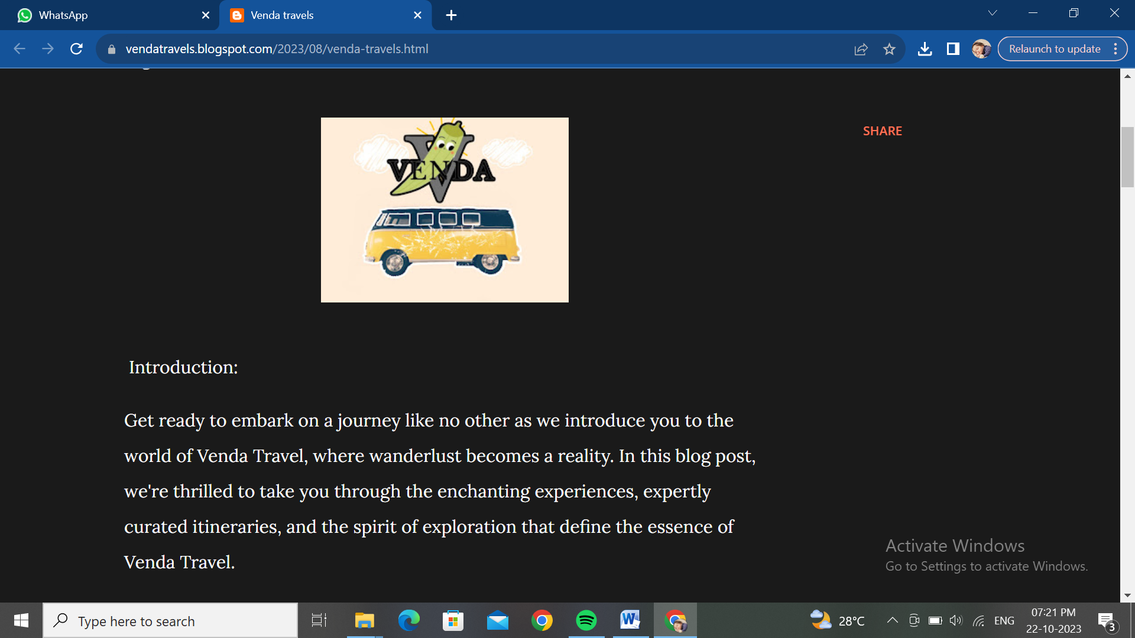

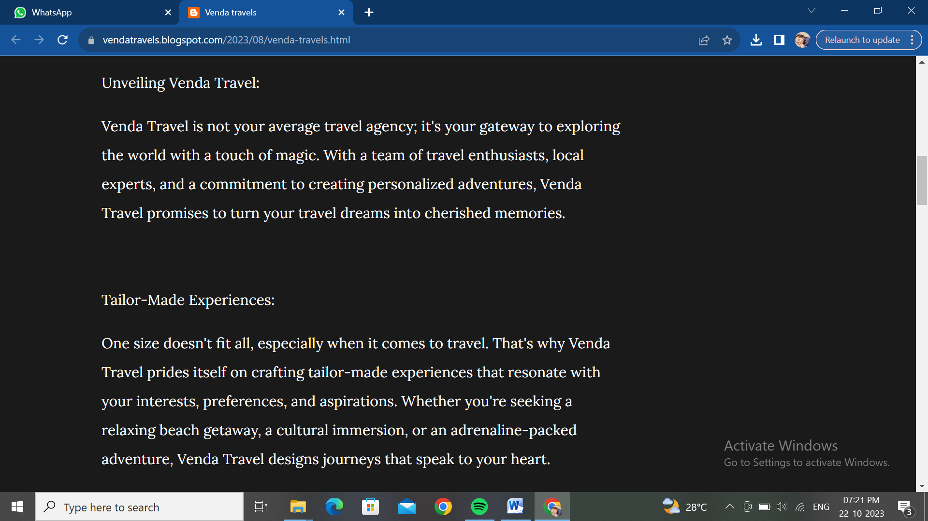

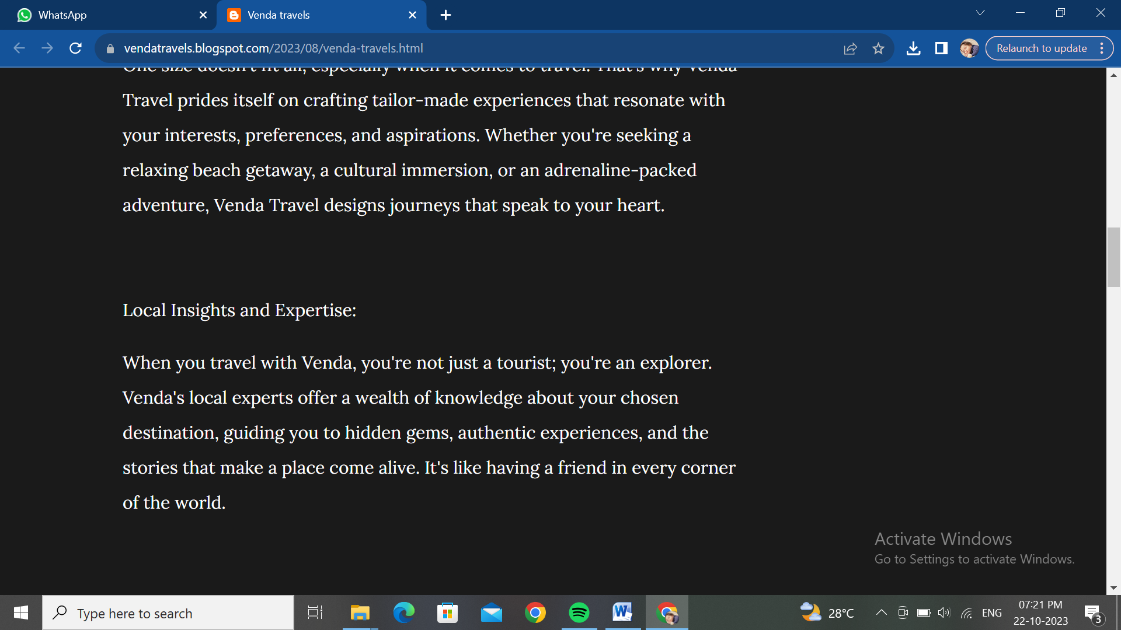

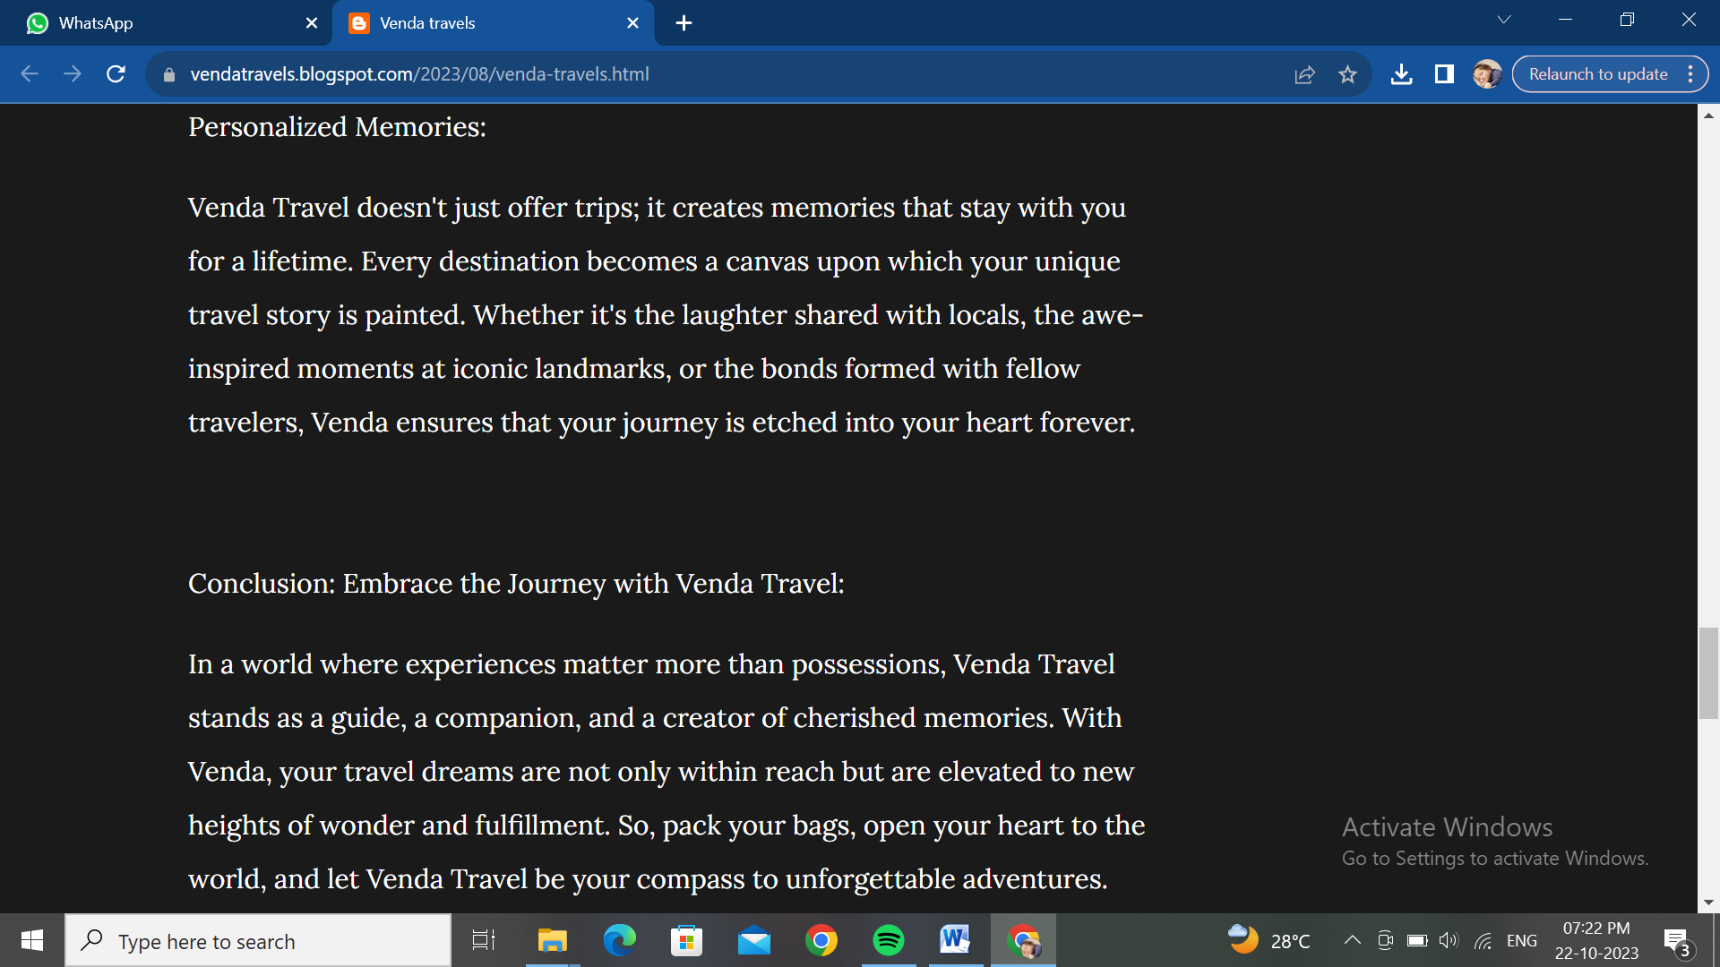

**2**.Create a new facebook page and post one social media poster for your brand.

Link: <https://m.facebook.com/story.php?story_fbid=pfbid02hdzeQpnLi8cMV8m7mfkFJq21LDSTGnpJ9gguoj2H4uYSWMyyVENLMBWhRaLF1DJxl&id=61552705107427&mibextid=ZbWKwL>

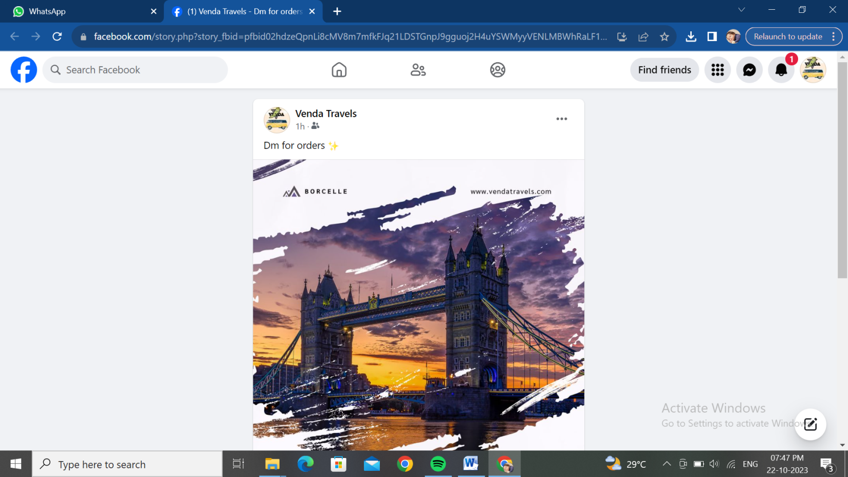

**3**.Create and design a social media advertisement poster using canva



4.Create email newsletter design using MailChimp or canva tool.

Link:Using canva

<https://vendatravels.blogspot.com/2023/09/email-newsletter-venda-travels.html>

